Encapsulation: Wrapping of data into a single unit and offer only the services or functionalities or the methods to the user is called Encapsulation.

Here wrapping of data into single unit is nothing but declaring a variable as private and call that variable into a public method is called as Data hiding. Where as Calling a method from one class to another class in which we just mention the name of the method but not the implementation is called Abstraction.

**Encapsulation = Data hiding + Abstraction**

**package** encapsulation;

**public** **class** BankServer {

**private** **int** cust1balance = 50000;

**public** **void** getBalance(**int** pin)

{

**if**(pin == 1234)

{

System.***out***.println("Your balance is :"+cust1balance);

}

**else**

{

System.***out***.println("Please check your pin and try again");

}

}

**public** **void** setBalance(**int** amount)

{

**if**(amount<=cust1balance)

{

cust1balance= cust1balance-amount;

System.***out***.println("Amount "+amount+"has been withdrawl your balance is :"+cust1balance);

}

}

}

**public** **class** ATMMachine {

**public** **void** balEnq(**int** pin)

{

BankServer bs = **new** BankServer();

bs.getBalance(pin);

}

**public** **void** withdrawl(**int** amount)

{

BankServer bs = **new** BankServer();

bs.setBalance(amount);

}

**public** **static** **void** main(String[] args) {

ATMMachine atm = **new** ATMMachine();

atm.balEnq(1234);

atm.withdrawl(5000);

bs.getBalance(pin);

}

Note : Text highlighted with yellow color represents Abstraction and text highlighted with red represents data hiding.

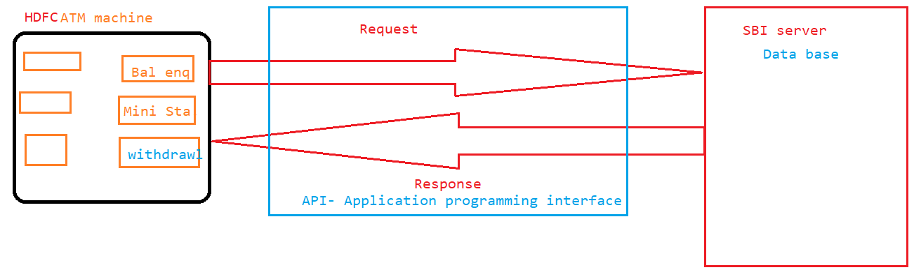

If any method which provides the information and starts with get word is called getter method.

If any method which is used to update the data and starts with set word is called as setter method.

**public** **void** getBalance(**int** pin)

{

**if**(pin == 1234)

{

System.***out***.println("Your balance is :"+cust1balance);

}

**else**

{

System.***out***.println("Please check your pin and try again");

}

}

**public** **void** setBalance(**int** amount)

{

**if**(amount<=cust1balance)

{

cust1balance= cust1balance-amount;

System.***out***.println("Amount "+amount+"has been withdrawl your balance is :"+cust1balance);

}

}

Through encapsulation we have achieved Security.

